URL SHORTENER WEB APPLICATION
Project Report

Introduction
In today’s digital world, sharing long URLs is inconvenient and sometimes confusing. To solve this problem, a URL Shortener Web Application is created. This application converts long URLs into short and easy-to-share links. The project is developed using Flask (Python) for backend and HTML, CSS, Bootstrap for frontend.
This project also allows users to view previously shortened URLs using a history page.

Objectives of the Project
The main objectives of this project are:
- To shorten long URLs into small and readable links
- To store original and shortened URLs in a database
- To allow users to view all previously shortened URLs
- To validate whether the entered URL is correct or not
- To understand Flask routing, ORM, and database integration

Technologies Used
- Frontend: HTML, CSS, Bootstrap
- Backend: Python (Flask Framework)
- ORM: SQLAlchemy
- Database: SQLite
- Editor: VS Code

Project Architecture
The project is divided into frontend and backend parts.
Folder Structure:
url_shortener/
│
├── app3.py
├── models.py
├── url_shortener.db
│
├── templates/
│ ├── index.html
│ └── history.html
│
├── static/
│ └── style.css

• app3.py contains main Flask logic and routes
• models.py contains database table structure
• templates folder contains HTML files
• static folder contains CSS styling

Working of the Project
1 Home Page
- User enters a long URL in the input field
- On clicking Shorten button, the URL is validated
- If URL is valid, a random short code is generated
- Short URL is displayed and can be copied
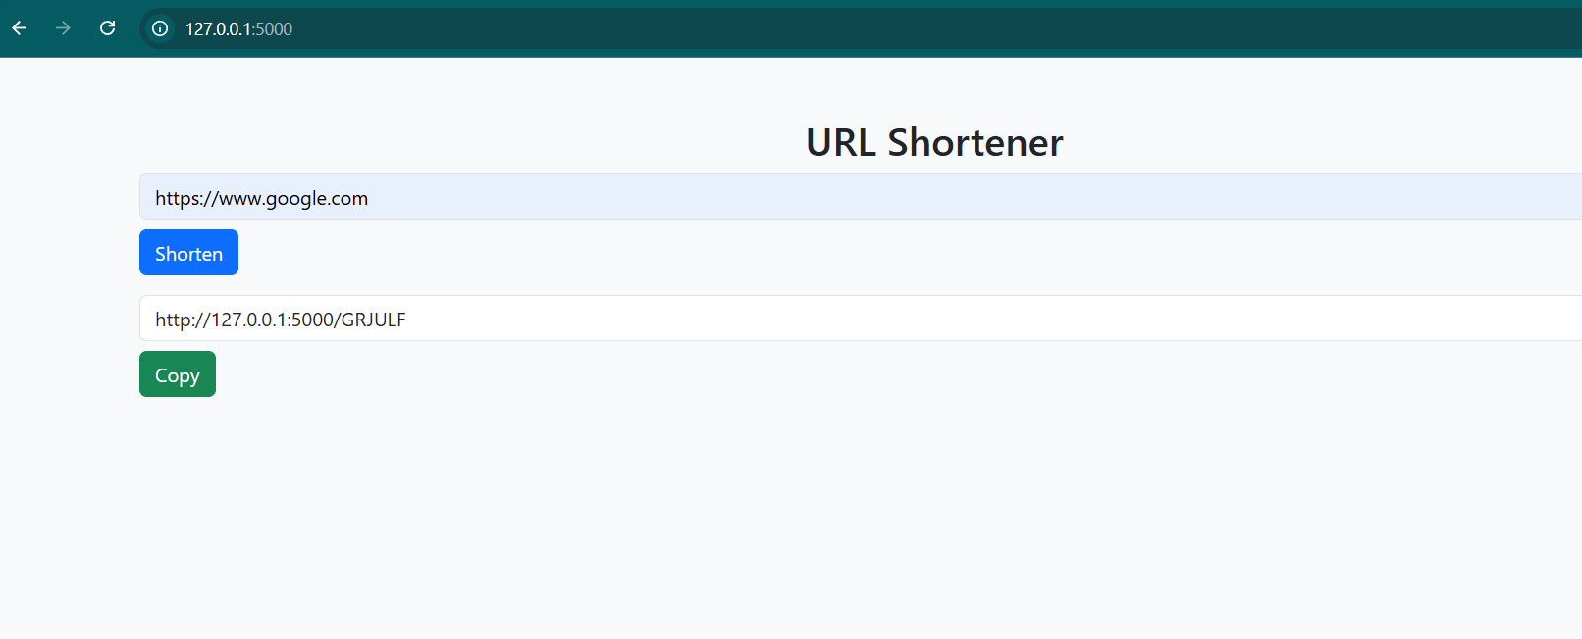
2 URL Redirection
- When the shortened URL is opened in the browser
- Flask searches for the short code in the database
- User is redirected to the original URL
3 History Page
- All previously shortened URLs are stored in SQLite database
- /history route displays original and shortened URLs in a table
- This helps users track previously generated links

URL Validation
To avoid incorrect inputs, URL validation is performed using the validators library.
- Valid URL → Saved in database
- Invalid URL → Error message displayed
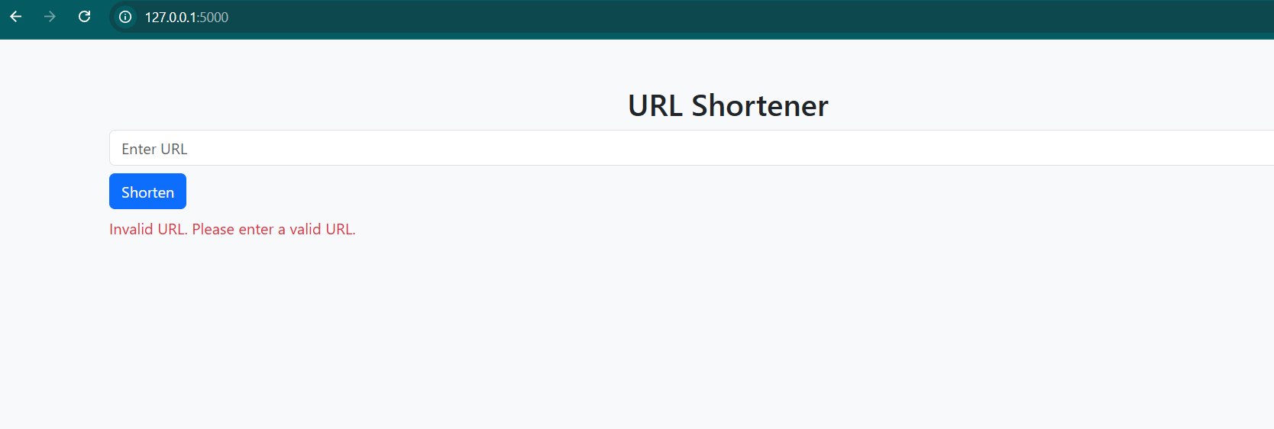

Database Design
The database contains a single table with the following fields:
Column |  |  | Name Description
id |  |  | Primary key
original_url |  |  | Long URL entered by user
short_code |  |  | Generated short URL code
created_at |  |  | Timestamp

Challenges Faced
- Flask version compatibility issue (before_first_request removed)
- Import error due to incorrect file naming (model.py vs models.py)
- Running the app from wrong directory
- Understanding Flask static folder usage
These issues were resolved by debugging and proper folder organization.

Result
The URL Shortener Web Application works successfully:
- URLs are shortened correctly
- Redirection works properly
- Database stores all records
- History page displays saved URLs
- Validation prevents wrong inputs

Conclusion
This project helped in understanding how a real-world web application works using Flask. It covers routing, database integration, validation, and frontend-backend interaction. The project can be further improved by adding user login, URL expiry, and click analytics.

